Expt. No: 4 | FLOW CHART
Date:18.12.2020 | FLOW CHART
Aim:
To draw a flowchart using raptor tool for the following
- Find area of a circle
- Find the biggest of two numbers
- Compute grade for given mark
- Find the sum and average of ‘N’ numbers
Description:
A flowchart is a diagrammatic representation of the logic for solving a task. A flowchart is drawn using boxes of different shapes with lines connecting them to show the flow of control. The purpose of flowchart is to make the logic of the program clearer in a visual form.
Symbols used in flow chart
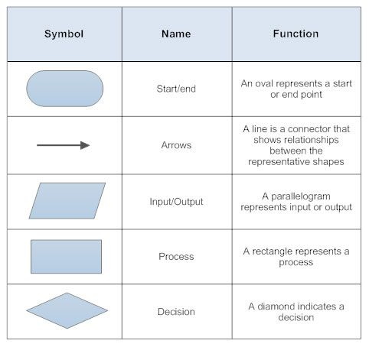
The most common symbols that are used to draw flowchart are process, decision, data, terminator, connector and flow lines.
Rules to be followed
- A flowchart should have a start and end
- The direction of flow in a flowchart must be from top to bottom and left to right
- The relevant symbols must be used while drawing a flowchart.
Control structures in flowchart
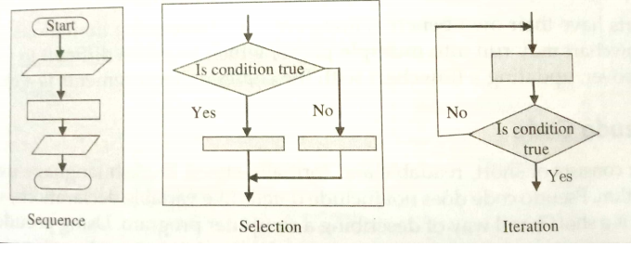
Task
- Find area of a circle
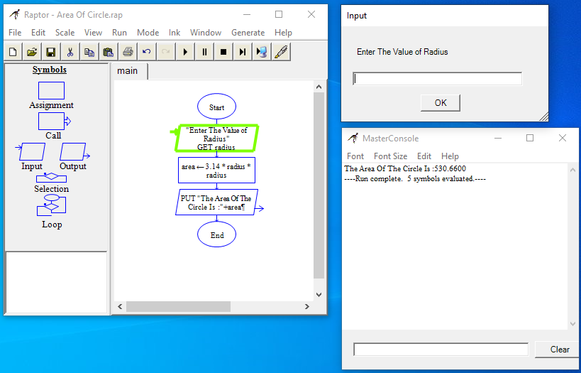
- Find the biggest of two numbers
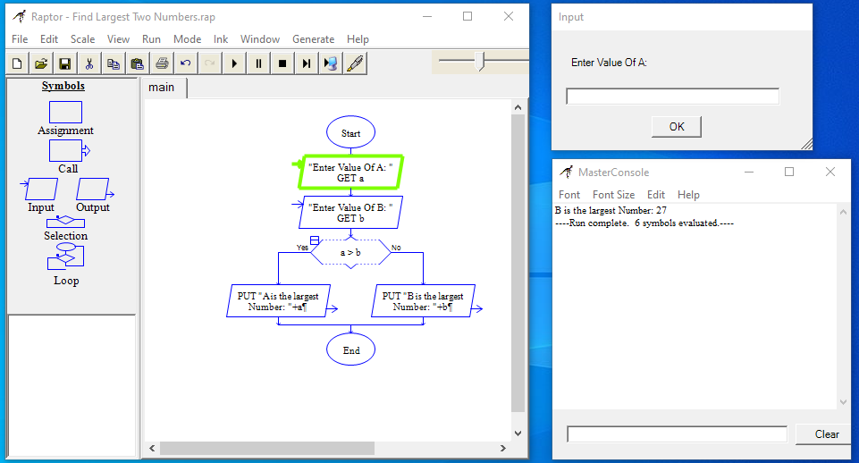
- Compute grade for given mark
- if mark >90 then “O” Grade
- if mark >80 then “A+” Grade
- if mark >70 then “A” Grade
- if mark >60 then “B+” Grade
- if mark >=50 then “B” Grade
- Otherwise “RA” Grade
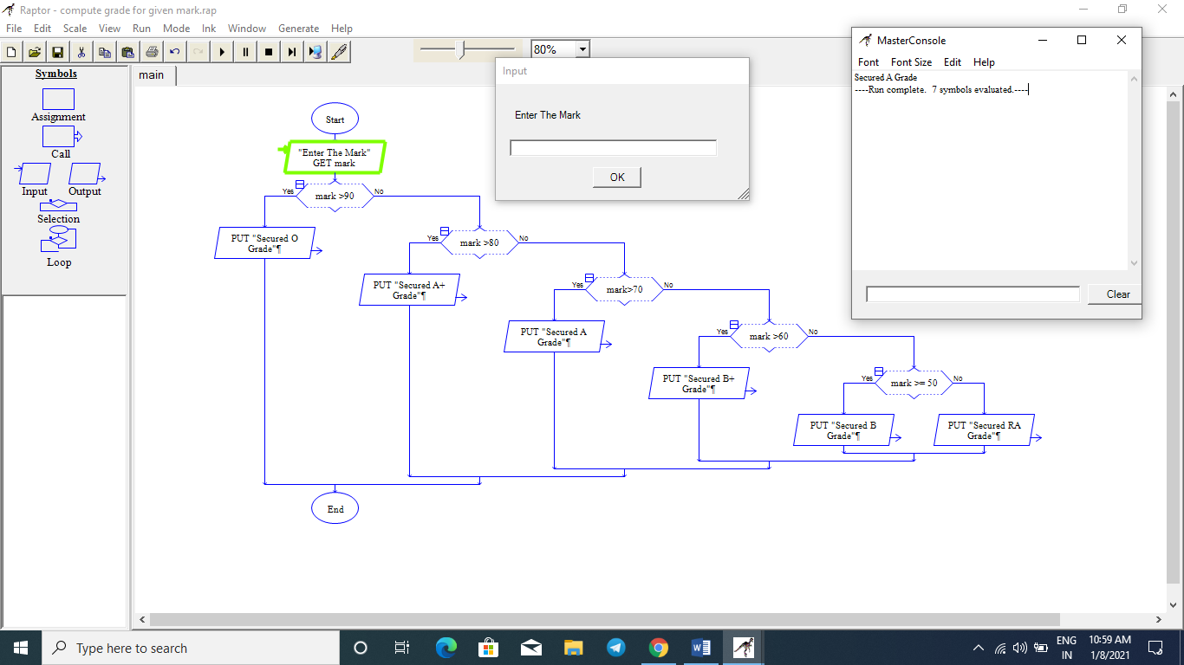

- Find the sum and average of ‘N’ numbers
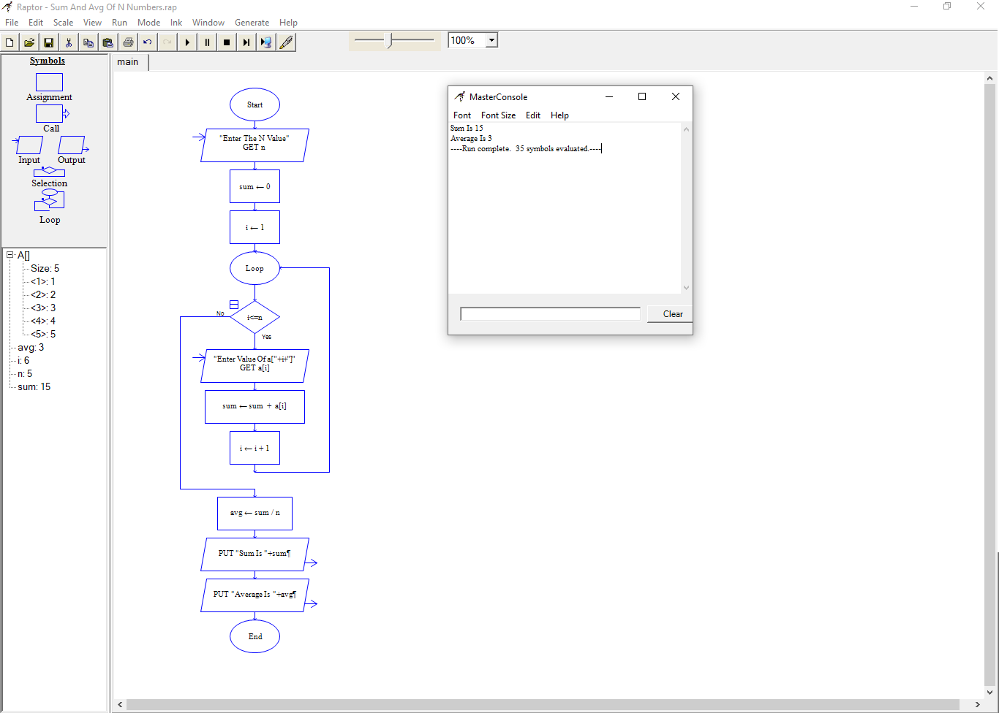

Result
Thus the flowchart is drawn successfully using raptor tool.

